Article | Source: Campus Sanofi | Read time: 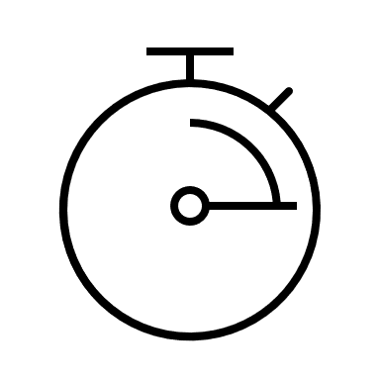 4 min
Cycle of Recurrence: A Challenge in CRSwNP Patients
Author: Sanofi Editorial Team
Chronic rhinosinusitis with nasal polyps (CRSwNP) is a type 2 inflammatory disease that is associated with frequent recurrence despite effective treatments.^{1–5} Understanding the role of type 2 inflammation, contributing factors, and treatment strategies, including biologics, can improve management and prevent relapse, potentially offering better outcomes for CRSwNP patients.^{1–7}

Overview of CRSwNP
Chronic rhinosinusitis with nasal polyps (CRSwNP) is a heterogenous disease with a wide spectrum of severity, primarily driven by type 2 inflammation. Key cytokines such as IL-4, IL-5 and IL-13, can contribute to the persistence and recurrence of nasal polyps.^{1,4} CRSwNP patients commonly experience persistent symptoms such as loss of smell, nasal congestion, facial pain, and rhinorrhea.^{1–3} Loss of smell is one of the most troublesome symptoms in CRSwNP and can be the first sign of the disease recurrence.^{1–3,8–10} Coexisting diseases such as asthma and allergic rhinitis, which are also driven by type 2 inflammation, can increase the overall disease burden.^{2,7} Understanding the mechanisms behind recurrence is essential in providing optimal care in CRSwNP patients.
Role of Type 2 Inflammation and Recurrence
Type 2 inflammation is central to the pathogenesis of CRSwNP, affecting up to 87% of patients.^{1,11} The elevated levels of type 2 cytokines (IL-4, IL-5, and IL-13) orchestrate the immune response pathway, leading to the recruitment and activation of eosinophils within nasal mucosa. IL-4 and IL-13 can contribute to barrier dysfunction and mucus production, which promotes nasal obstruction, smell loss and potentially nasal polyp formation.^{1,7} Persistent type 2 inflammation is also associated with olfactory dysfunction, affecting up to 91% of CRSwNP patients.^{1,8} The degree of smell loss correlates with mucosal inflammation,⁹ significantly impacting the patient’s quality of life (QoL).⁸
Additionally, type 2 inflammation can contribute to nasal polyp recurrence, with up to 40% of patients experiencing recurrence within 6 months post-surgery.¹² Furthermore, type 2 inflammation can influence both clinical manifestations and response to medical and surgical interventions,^{4,12} necessitating alternative strategies that target type 2 inflammatory pathways for preventing recurrence and improving clinical outcomes of CRSwNP patients.^{1,6,7,13}
Prevalence and Global Burden of Recurrence
CRSwNP affects approximately 1.1%–4.3% of the global population,⁷ with prevalence increasing with age, peaking between 40–60 years, and decreasing after 70 years.^{2,3,14,15} The recurrence of nasal polyps after surgical interventions remains a significant challenge in CRSwNP patients.² Recurrence rates range from 20%–60% within 1.5–4 years after surgery, with higher rates in patients with severe disease or type 2 inflammatory coexisting diseases.^{2,4} This recurrence often leads to additional interventions, thereby exacerbating the overall disease burden.^{2,16,17}
Understanding Recurrence in CRSwNP
Recurrence of CRSwNP is defined as the persistence of postoperative endoscopic edema or polyps for more than one follow-up visit, lasting at least 3 months, requiring changes in treatment, and not attributable to concurrent upper respiratory infection.¹² The presence of chronic type 2 inflammation may contribute to the recurrence of CRSwNP.²
Factors associated with the recurrence of nasal polyps in CRSwNP patients include inadequate medical therapy, a history of endoscopic sinus surgery (ESS), and coexisting diseases such as asthma, aspirin-exacerbated respiratory disease, allergic rhinitis etc.^{1,2,4,5,7} Loss of smell often recurs within 3 months post-surgery and can be the first sign of the disease recurrence,^{8–10,18} followed by sinonasal edema. Nasal obstruction and facial pain appear later in the relapse process.¹⁸
Severity of CRSwNP symptoms post-surgery over time¹⁸
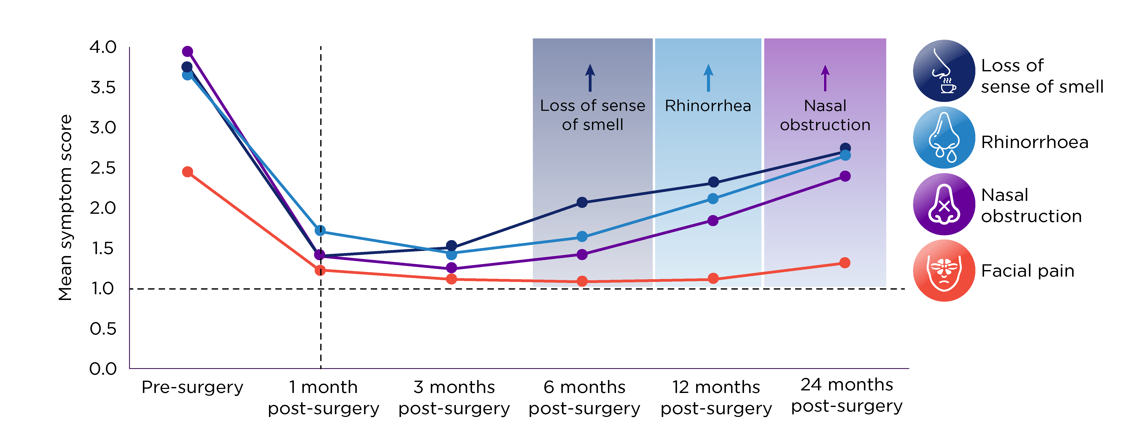
A study reported that over 1/3rd of CRSwNP patients experience nasal polyp recurrence within 6 months of surgery, with the rates increasing over time.⁵ Thus, the recurrence of nasal polyps could be a function of untreated chronic inflammation.²

Postoperative recurrence of nasal polyps and sinonasal edema during follow-up⁵
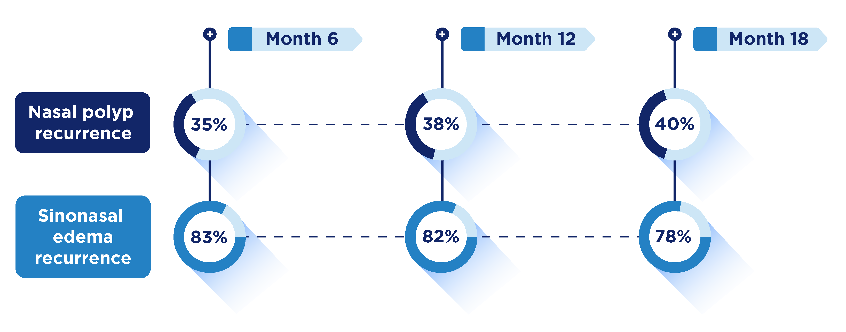
Clinical Challenges and Management of CRSwNP Recurrence
A multimodal treatment approach is recommended for managing CRSwNP.⁴ First-line therapy includes long-term intranasal corticosteroids (INCS), which help in reducing polyp size and recurrence after ESS.^{3,4,13,16,17} The European Position Paper on Rhinosinusitis and Nasal Polyps (EPOS) 2020 guideline recommends short courses (no more than 1–2 annually) of systemic corticosteroids (SCS),³ for severe exacerbations, particularly in patients with partial or uncontrolled disease.^{3,17,19} Nearly 2/3rd of CRSwNP patients use SCS at some time over 12 months, with nearly 23% exceeding a cumulative dose of 400 mg annually, highlighting corticosteroid burden and its associated short-term and long-term adverse events, especially for patients with coexisting asthma.²⁰ Surgery, such as ESS, aims to remove nasal polyp tissue and diseased mucosa, and is considered when medical treatments are inadequate to control symptoms.^{16,17,21,22} However, these treatments may provide temporary symptom relief but do not fully address the underlying type 2 inflammation, potentially leading to nasal polyps recurrence and side effects.^{2,5,7,12,16}
Clinical burden in CRSwNP patients^{4,5}
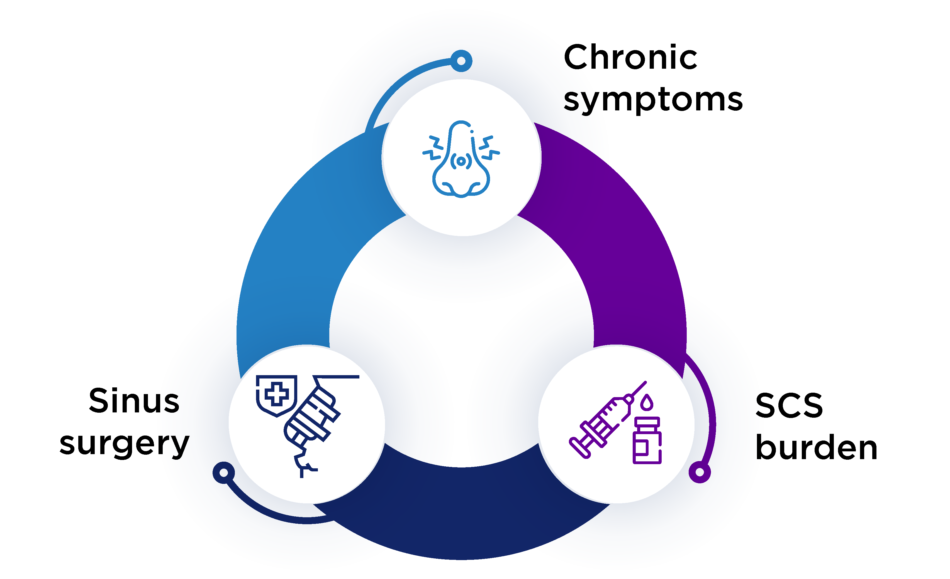
The EPOS 2020 guideline suggests that identifying Th-2 inflammation in CRSwNP through endotyping can predict recurrence and guide decisions on biologic treatments.³ Biologics targeting type 2 inflammation have emerged as a promising strategy for managing recurrence in CRSwNP patients, particularly those with severe or refractory disease.^{1,8,13,16,21} The EPOS 2020 and International consensus statement on allergy and rhinology (ICAR) 2021 guidelines recommend biologics for CRSwNP patients who failed to respond to conventional therapies,^{3,23} and meet at least 3 of the following 5 criteria: evidence of type 2 inflammation, need for SCS, significantly impaired QoL, loss of smell and coexisting asthma.³ Response to biologics is assessed based on nasal polyp reduction, decreased corticosteroid use, improved QoL and smell, and better control of coexisting diseases.³ If improvement is acceptable at 6 months, CRSwNP treatment may continue, with re-evaluation at 12 months.²⁴
Summary
- CRSwNP is predominently a type 2 inflammatory condition, mediated by elevated cytokines (IL-4, IL-5, and IL-13), that can lead to recurrent nasal polyps and symptoms such as smell loss and nasal congestion^{1,2,7}
- Despite standard of care treatments such as INCS, SCS, and ESS, recurrence is common, especially in patients with coexisting diseases like asthma^{2,5,7,12,16}
- Factors such as persistent type 2 inflammation, inadequate treatment and comorbid type 2 diseases are associated with nasal polyp recurrence^{1–5,7}
- A multimodal approach, including INCS, short-course SCS, sinus surgery and biologics targeting type 2 inflammation, shows promise in reducing recurrence and improving long-term disease control in CRSwNP patients^{1,4,8,12,13,16,21}
References:
- Bachert C, Hicks A, Gane S, et al. The interleukin-4/interleukin-13 pathway in type 2 inflammation in chronic rhinosinusitis with nasal polyps. Front Immunol. 2024;15:1356298.
- Bachert C, Bhattacharyya N, Desrosiers M, Khan AH. Burden of disease in chronic rhinosinusitis with nasal polyps. J Asthma Allergy. 2021;14:127–134.
- Fokkens WJ, Lund VJ, Hopkins C, et al. European position paper on rhinosinusitis and nasal polyps 2020. Rhinology. 2020;58(Suppl S29):1–464.
- De Corso E, Settimi S, Montuori C, et al. How to manage recurrences after surgery in CRSwNP patients in the biologic era: a narrative review. Acta Otorhinolaryngol Ital. 2023;43(Suppl.1):S3–S13.
- DeConde AS, Mace JC, Levy JM, Rudmik L, Alt JA, Smith TL. Prevalence of polyp recurrence after endoscopic sinus surgery for chronic rhinosinusitis with nasal polyposis. Laryngoscope. 2017;127(3):550–555.
- Shah SA, Kobayashi M. Pathogenesis of chronic rhinosinusitis with nasal polyp and a prominent T2 endotype. Heliyon. 2023;9(9):e19249.
- Maspero J, Adir Y, Al-Ahmad M, et al. Type 2 inflammation in asthma and other airway diseases. ERJ Open Res. 2022;8(3):00576–2021.
- Soler ZM, Nash S, Lane AP, et al. Reduced sense of smell in patients with severe chronic rhinosinusitis and its implications for diagnosis and management: A narrative review. Adv Ther. 2024;41(12):4384–4395.
- Yan X, Whitcroft KL, Hummel T. Olfaction: Sensitive indicator of inflammatory burden in chronic rhinosinusitis. Laryngoscope Investig Otolaryngol. 2020;5(6): 992–1002.
- Rouyar A, Classe M, Gorski R, et al. Type 2/Th2-driven inflammation impairs olfactory sensory neurogenesis in mouse chronic rhinosinusitis model. Allergy. 2019;74(3):549–559.
- Stevens WW, Peters AT, Tan BK, et al. Associations between inflammatory endotypes and clinical presentations in chronic rhinosinusitis. J Allergy Clin Immunol Pract. 2019;7(8):2812–2820.e3.
- Levi L, Havazelet S, Reuven Y, et al. Patterns of recurrence in patients with CRSwNP who underwent complete FESS. Eur Arch Otorhinolaryngol. 2024;281(11):5847–5856.
- Han JK, Bosso JV, Cho SH, et al. Multidisciplinary consensus on a stepwise treatment algorithm for management of chronic rhinosinusitis with nasal polyps.
Int Forum Allergy Rhinol. 2021;11(10):1407–1416.
- Merrill T, Kanaan A. Managing chronic rhinosinusitis with nasal polyps in the elderly: Challenges and solutions. Clin Interv Aging. 2022;17:685–698.
- Cavaliere C, Masieri S, Begvarfaj E, et al. Long-term perspectives on chronic rhinosinusitis with nasal polyps: Evaluating recurrence rates after functional endoscopic sinus surgery in the biologics era-a 5-year follow-up study. J Pers Med. 2024;14(3):297.
- Desrosiers M, Mannent LP, Amin N, et al. Dupilumab reduces systemic corticosteroid use and sinonasal surgery rate in CRSwNP. Rhinology. 2021;59(3):301–311.
- Gevaert P, Han JK, Smith SG, et al. The roles of eosinophils and interleukin-5 in the pathophysiology of chronic rhinosinusitis with nasal polyps. Int Forum Allergy Rhinol. 2022;12(11):1413–1423.
- Bakhshaee M, Sharifian MR, Ghazizadeh AH, Nahid K, Samani KJ. Smell decline as a good predictor of sinonasal polyposis recurrence after endoscopic surgery. Iran J Otorhinolaryngol. 2016;28(85):125–134.
- Rank MA, Wonnaparhown AM, Freeman CM. Recent guidelines addressing chronic rhinosinusitis with nasal polyps: practical aspects. Pol Arch Intern Med. 2023;133(11):16611.
- Han JK, Silver J, Dhangar I, Veeranki P, Deb A. Quantifying corticosteroid burden in chronic rhinosinusitis with nasal polyps: A retrospective US database study. Ann Allergy Asthma Immunol. 2024:S1081-1206(24)01574–6.
- Norelli F, Schiappoli M, Senna G, et al. Adherence to intranasal steroids in chronic rhinosinusitis with nasal polyposis prior to and during biologic therapy: A neglected matter. J Clin Med. 2024;13(4):1066.
- Buchheit KM and Holbrook EH. Chronic rhinosinusitis with nasal polyposis: Management and prognosis. UpToDate. 2023. Available at UpToDate. Accessed on 22 April 2025.
- Orlandi RR, Kingdom TT, Smith TL, et al. International consensus statement on allergy and rhinology: rhinosinusitis 2021. Int Forum Allergy Rhinol. 2021;11(3):213–739.
- Fokkens WJ, Viskens AS, Backer V, et al. EPOS/EUFOREA update on indication and evaluation of Biologics in Chronic Rhinosinusitis with Nasal Polyps 2023. Rhinology. 2023;61(3):194–202.

