Article | Source: Campus Sanofi | Read time: 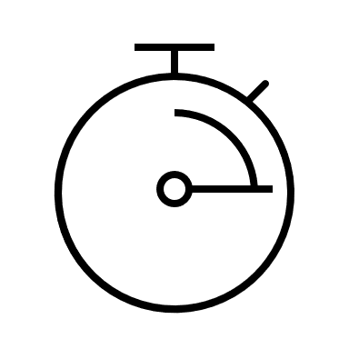 3 min
Chronic Rhinosinusitis with Nasal Polyps: More Than Just Nasal Obstruction
Author: Sanofi Editorial Team
Chronic rhinosinusitis with nasal polyps (CRSwNP) is a complex disease state that extends well beyond nasal congestion.^{1–3} Understanding the underlying mechanisms, including the roles of type 2 inflammatory cytokines (IL-4, IL-5 and IL-13), nasal mucosa remodeling, and nasal polyp growth, is essential for effective management of the disease and recurrence of nasal polyps.^{1,3–5}


Implications of Nasal Congestion in CRSwNP
Chronic rhinosinusitis with nasal polyps (CRSwNP) is a persistent inflammatory disease that affects the paranasal sinuses and nasal passage lining, characterized by the presence of nasal polyps, and lasting for ≥12 weeks.^{6,7} These polyps can cause significant nasal congestion,^{3,4} which can obstruct airflow to the olfactory cleft,⁸ leading to a range of symptoms that may impact a patient’s quality of life (QoL).^{3,4} While nasal congestion is a prominent symptom, it is important to understand that it is a manifestation of the underlying disease rather than the disease itself.⁹
Inflammatory changes associated with CRSwNP⁷
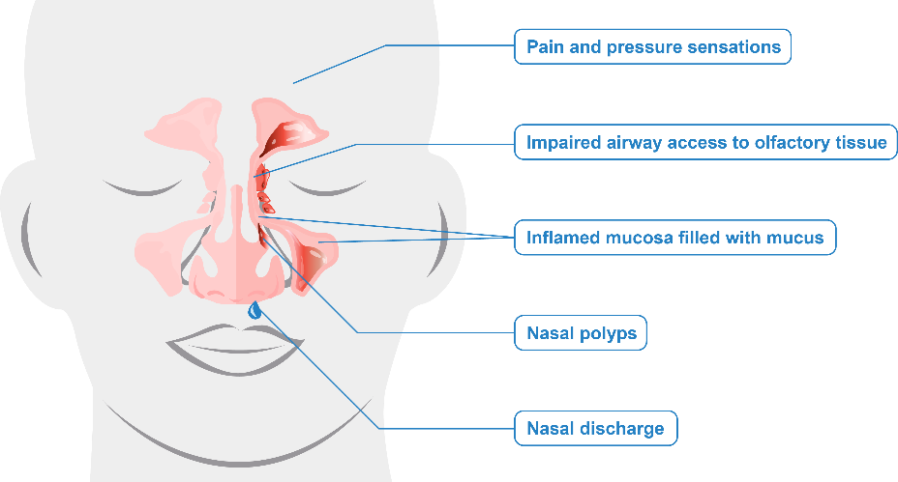
Addressing nasal congestion without targeting the underlying inflammation can potentially lead to recurrence and ongoing symptoms.^{6,10–12} Therefore, effective management of CRSwNP requires a comprehensive approach that targets the root cause of the inflammation.^{1,3–5,10}
Roles of Type 2 Inflammation in CRSwNP
CRSwNP is predominantly a type 2 inflammatory disease, marked by elevated levels of type 2 inflammatory cytokines such as IL-4, IL-5, and IL-13.¹ This chronic inflammatory state can lead to the development of nasal polyps, which obstruct nasal airways and the olfactory cleft.¹
Type 2 inflammation can be influenced by environmental factors such as allergens, pathogens (bacteria/viruses), or irritants etc., which activate type 2 innate lymphoid cells (ILC2) and T-helper 2 (Th2) cells.^{1,10} These cells trigger an inflammatory response and promote the release of type 2 inflammatory cytokines in the nasal mucosa, contributing to the pathophysiology of CRSwNP.
IL-4, IL-5, and IL-13 are key drivers of type 2 inflammation in CRSwNP^{1,10}
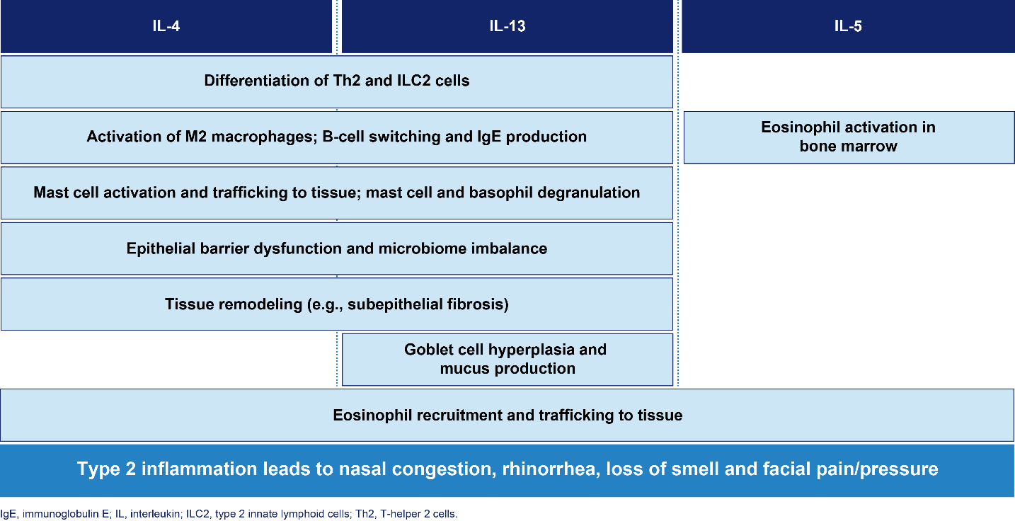
Nasal Mucosa Remodeling in CRSwNP
Chronic type 2 inflammation causes abnormal cellular changes in the nasal mucosa, leading to mucosal hypertrophy, fibrosis, collagen deposition, and angiogenesis.¹³ In CRSwNP, type 2 inflammation can promote nasal polyp formation via IL-4 and IL-13, which increases expression of the protein periostin. This promotes fibrosis, edema and barrier dysfunction.¹ Eosinophil infiltration leads to the release of inflammatory mediators, causing further epithelial damage.¹³ Additionally, type 2 inflammatory cytokines enhance extracellular matrix protein deposition, leading to mucosal rigidity, worsening nasal congestion and potentially nasal polyp formation.¹⁴

Epithelial remodeling in CRSwNP^{1,5,10,13}
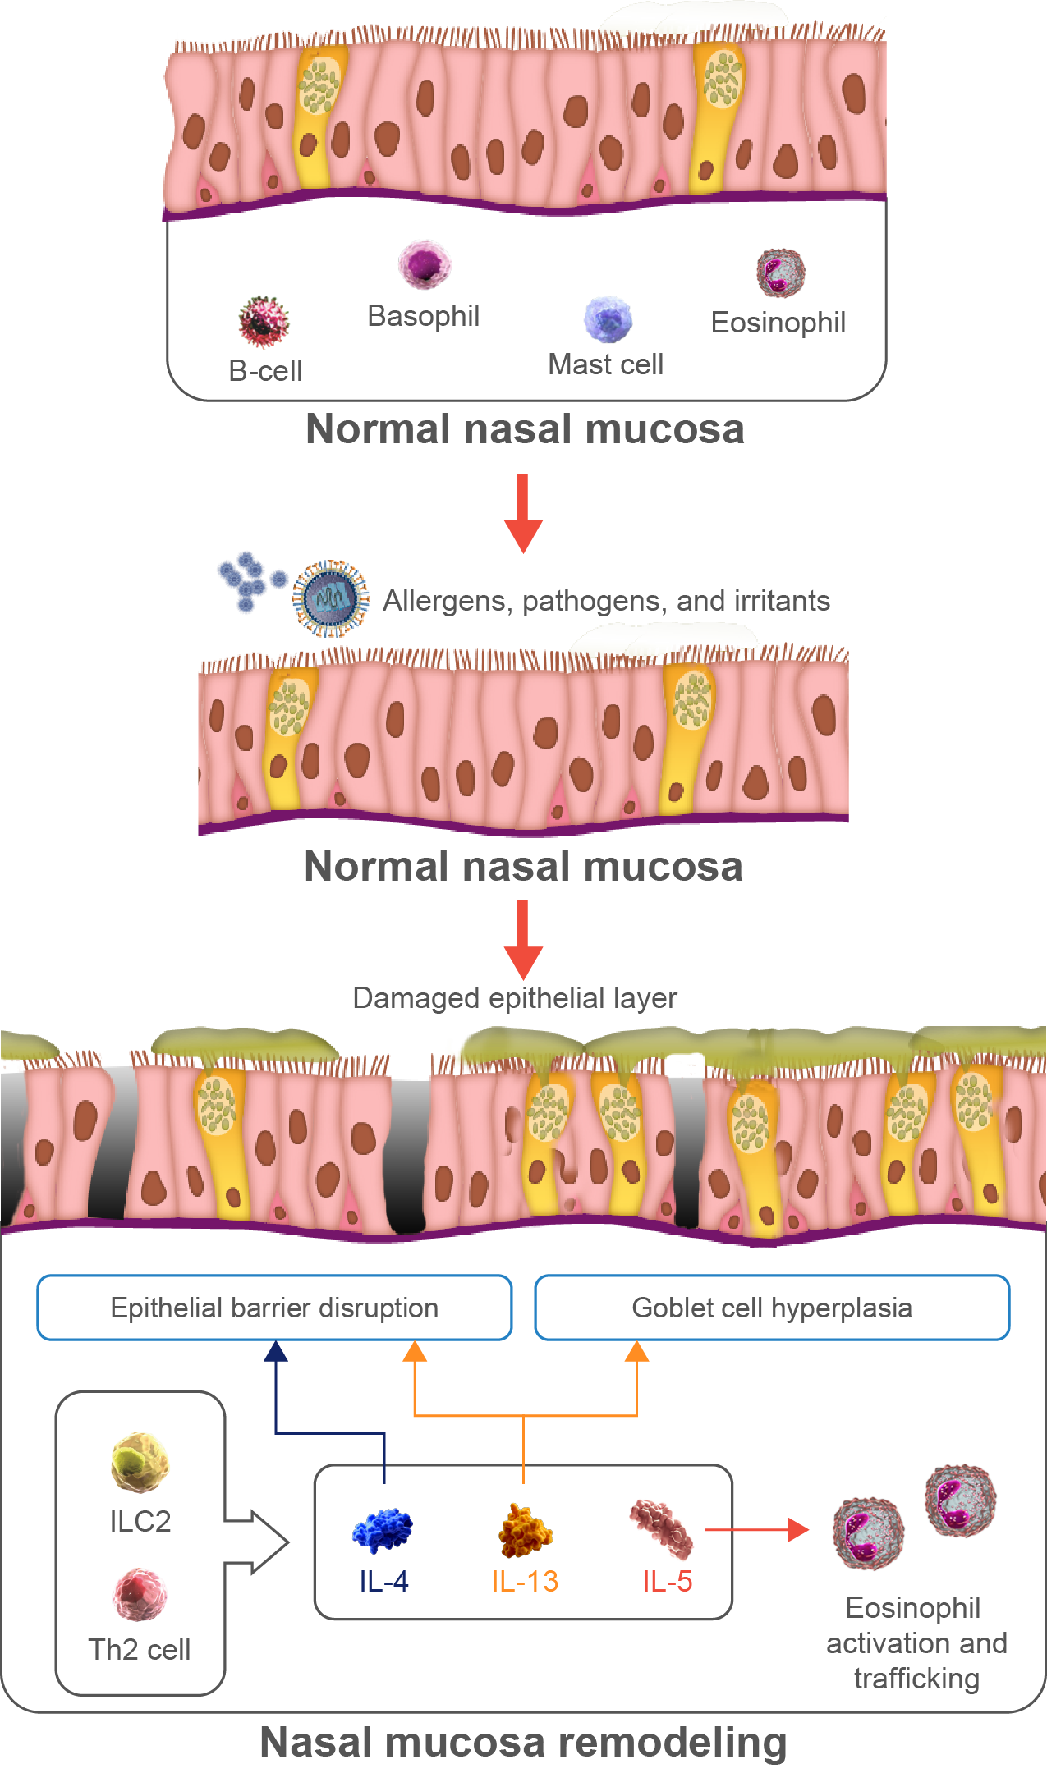
Nasal Polyps Growth and Recurrence
Nasal polyps are benign, edematous, inflammatory lesions of the paranasal sinuses that can obstruct the nasal airway and olfactory cleft.¹ Their growth is driven by type 2 inflammation, particularly IL-4, IL-5, and IL-13.
- IL-4 and IL-13 activates M2 macrophages, promoting fibrin deposition, edematous remodeling, and membrane thickening, which can potentially lead to nasal polyp formation.¹⁰ Increased mucus production and impaired epithelial barrier function makes it more susceptible to allergens and pathogens.^{1,10}
- IL-5, through its effects on eosinophil, can contribute to the pathogenesis of CRSwNP.⁵ Activation of eosinophils, mast cells, and basophils leads to nasal polyp formation.⁷
Healthy and severe CRSwNP⁷
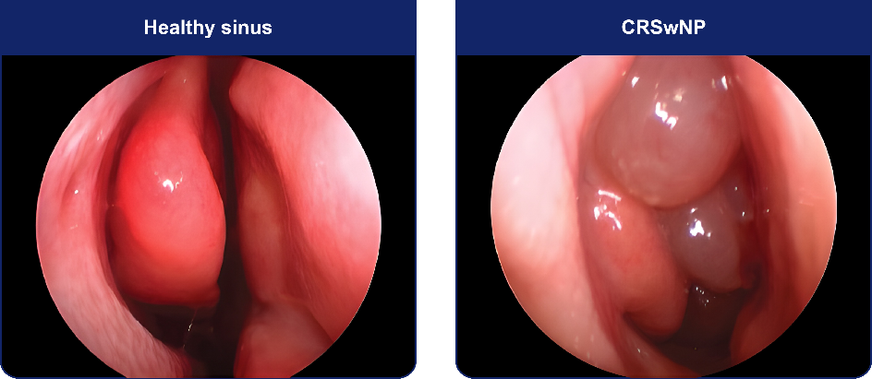

Nasal polyp recurrence remains a significant challenge in the management of CRSwNP.^{3,6,7,10,11,13} Factors associated with the recurrence of nasal polyps include:
- Persistent type 2 inflammation can drive nasal polyp growth despite initial treatment.^{3,10,14}
- Comorbid conditions such as asthma, allergic rhinitis, and aspirin-exacerbated respiratory disease.^{3,10}
- Genetic factors increase susceptibility; first-degree relatives of CRSwNP patients are at 4-fold increased risk.⁵
Chronic Symptoms of CRSwNP
Chronic rhinosinusitis affects 5%–12% of the general population, of which approximately 20% have CRSwNP.³ Common symptoms include:^{2,3,5}
- Nasal congestion/obstruction
- Rhinorrhea
- Hyposmia or anosmia (partial or total smell loss, respectively)
- Facial pain/pressure
These symptoms can have a profound effect on patient’s quality of life (QoL).^{3,4}
CRSwNP: Impact on patient’s quality of life³
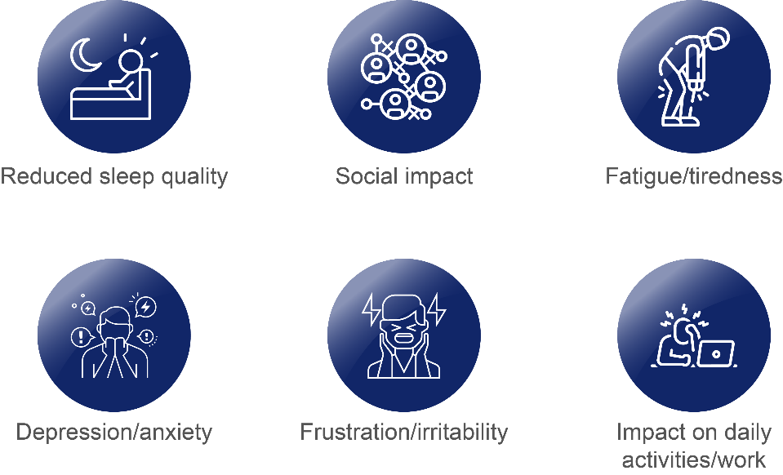
The chronic nature of this condition requires long-term management strategies to control symptoms and prevent exacerbations.¹⁴
Smell Loss in CRSwNP
Loss of the sense of smell is a major symptom for individuals affected by CRSwNP,¹⁵ affecting 83%–91% of patients.¹² Many CRSwNP patients experience a reduced (hyposmia) or complete loss of smell (anosmia) due to the obstruction of olfactory cleft by nasal polyps and inflammation in the nasal cavity.¹ This condition may significantly impair patients’ quality of life (QoL),¹ inflicting repercussions on activities such as eating and personal hygiene. Additionally, patients may also experience emotional and psychological sequelae, including depression and anxiety.^{3,4} Even after surgery, relapse may occur in a significant percentage of CRSwNP patients,⁷ and anosmia/hyposmia can be an early indicator of disease recurrence.¹²
Summary
- In CRSwNP, nasal congestion is a key symptom but does not fully capture the multitude of other symptoms³
- Type 2 inflammation, driven by IL-4 and IL-13, can contribute to nasal polyp formation, mucus production, and epithelial barrier dysfunction^{1,10}
- Chronic type 2 inflammation causes abnormal changes in nasal mucosa, worsening congestion and potentially leading to nasal polyp growth^{13,14}
- Persistent inflammation, comorbid conditions and genetic predisposition are associated with the recurrence of nasal polyps^{1,3,5,7,10,14}
- Common symptoms include nasal congestion, rhinorrhea, loss of smell, and facial pain/pressure,^{2,3,5} impacting daily activities and mental health of CRSwNP patients^{3,4}

References
- Bachert C, Hicks A, Gane, et al. The interleukin-4/interleukin-13 pathway in type 2 inflammation in chronic rhinosinusitis with nasal polyps. Front Immunol. 2024;15:1356298.
- Fokkens WJ, Lund VJ, Hopkins c, et al. European Position paper on Rhinosinusitis and Nasal Polyps 2020. Rhinology. 2020;58(Suppl 29):1-464.
- Mullol J, Azar A, Buchheit KM, Hopkins C, Bernstein JA. Chronic Rhinosinusitis With Nasal Polyps: Quality of Life in the Biologics Era. J Allergy Clin Immunol Pract. 2022;10(6):1434-1453.e9.
- Hopkins C, Mullol J, Khan AH, et al. Impact of Dupilumab on Sinonasal Symptoms and Outcomes in Severe Chronic Rhinosinusitis With Nasal Polyps. Otolaryngol Head Neck Surg. 2024;170(4):1173-1182.
- Stevens WW, Schleimer RP, Kern RC. Chronic Rhinosinusitis with Nasal Polyps. J Allergy Clin Immunol Pract. 2016;4:565-572.
- Buchheit KM and Holbrook EH. Chronic rhinosinusitis with nasal polyposis: Management and prognosis. UpToDate. 2023. Available at UpToDate. Accessed on 13 Nov 2024.
- Schleimer RP. Immunopathogenesis of Chronic Rhinosinusitis and Nasal Polyposis. Annu Rev Pathol. 2017;12:331-357.
- Ye P, He S, Tang, S, et al. Improvement of subjective olfactory dysfunction in chronic rhinosinusitis with nasal polyps after endoscopic sinus surgery. Front. Surg. 2022;9:870682.
- Nasal Obstruction. Available at Hopkins Medicine. Accessed on 13 Nov 2024.
- Maspero J, Adir Y, Al-Ahmad M, et al. Type 2 inflammation in asthma and other airway diseases. ERJ Open Res. 2022;8(3):00576-2021.
- Tsunemi Y, Nakayama T, Kashiwagi T, Akutsu M, Saito S, Haruna S. Long-Term Efficacy of Dupilumab for Eosinophilic Chronic Rhinosinusitis. Am J Rhinol Allergy. 2024;38(1):14-22.
- Yan X, Whitcroft KL, Hummel T. Olfaction: Sensitive indicator of inflammatory burden in chronic rhinosinusitis. Laryngoscope Investig Otolaryngol. 2020;5(6):992-1002.
- Lee K, Tai J, Lee SH, et al. Advances in the knowledge of the underlying airway remodeling mechanisms in chronic rhinosinusitis based on the endotypes: A review. Int J Mol Sci. 2021;92:910.
- Gong X, Han Z, Fan H, et al. The interplay of inflammation and remodeling in the pathogenesis of chronic rhinosinusitis: current understanding and future directions. Front Immunol. 2023;14:1238673.
- Fokkens WJ, De Corso E, Backer V, et al. EPOS2020/EUFOREA expert opinion on defining disease states and therapeutic goals in CRSwNP. Rhinology. 2024;62(3):287-298.

